[DCO-2449] Motive Financial - Infinity Forgot Password and Add Phone number control fail to present visible focus Created: 30/Apr/24 Updated: 06/May/24
Status: | In External Review
Project: | Journey Manager
Components: | None
Affects versions: | None
Fix versions: | Accessibility

Type: | Story | Priority: | None
Reporter: | Sanya Khandhuja | Assignee: | Fusi Olateru
Resolution: | Unresolved | Votes: | 0
Labels: | Motive, MotiveAuthenticated
Remaining Estimate: | Not Specified
Time Spent: | Not Specified
Original estimate: | Not Specified

Attachments: | image-20240430-182205.png image-20240430-182221.png
QA Bug Count: | 0
Days Open: | 5 days
Bug Count: | 0
Hours Variance: | 0
Hours Remaining: | 0
Hours Target PMO: | 0
Sprint:
Days Open: | 6

Description

The “Choose a forgot password question” and add phone number controls fail to present
a visible focus indicator when given focus.
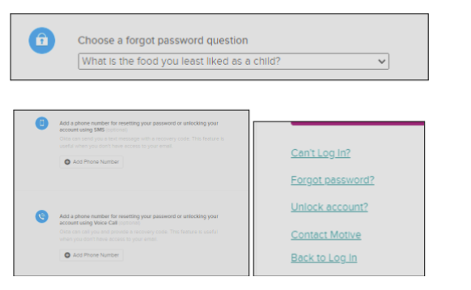

■ Recommendation: Ensure that all controls in focus present a visible focus indicator.

Comments

Comment by Fusi Olateru [ 03/May/24 ]
okta - will change after OIE upgrade. Cannot change this.
Generated at Mon May 06 21:51:14 UTC 2024 by Ian Hicks using Jira 1001.0.0-SNAPSHOT#100252-rev:aa264b414382dcd2bbea0c3e63c78e358e7de0d5.

